NOTICE AVISO
通知 PAUNAWA
IDLING LIMITED TO 2 MINUTES (30 SECONDS IF WITHIN 100 FEET OF A SCHOOL ZONE)

PARADA LIMITADA A 2 MINUTOS (30 SEGUNDOS SI ES DENTRO DE 100 PIES DE UNA ZONA ESCOLAR)

空轉僅限於 2分鐘 (在學校100英呎範圍內限於30秒鐘)

ANG IDLING AY LIMITADO SA 2 MINUTO (30 SEGUNDO KUNG NASA LOOB NG PALUGIT NG100 TALAMPAKAN MULA SA ISANG PAARALAN)

San Francisco Environment Code Section 25.5(3)
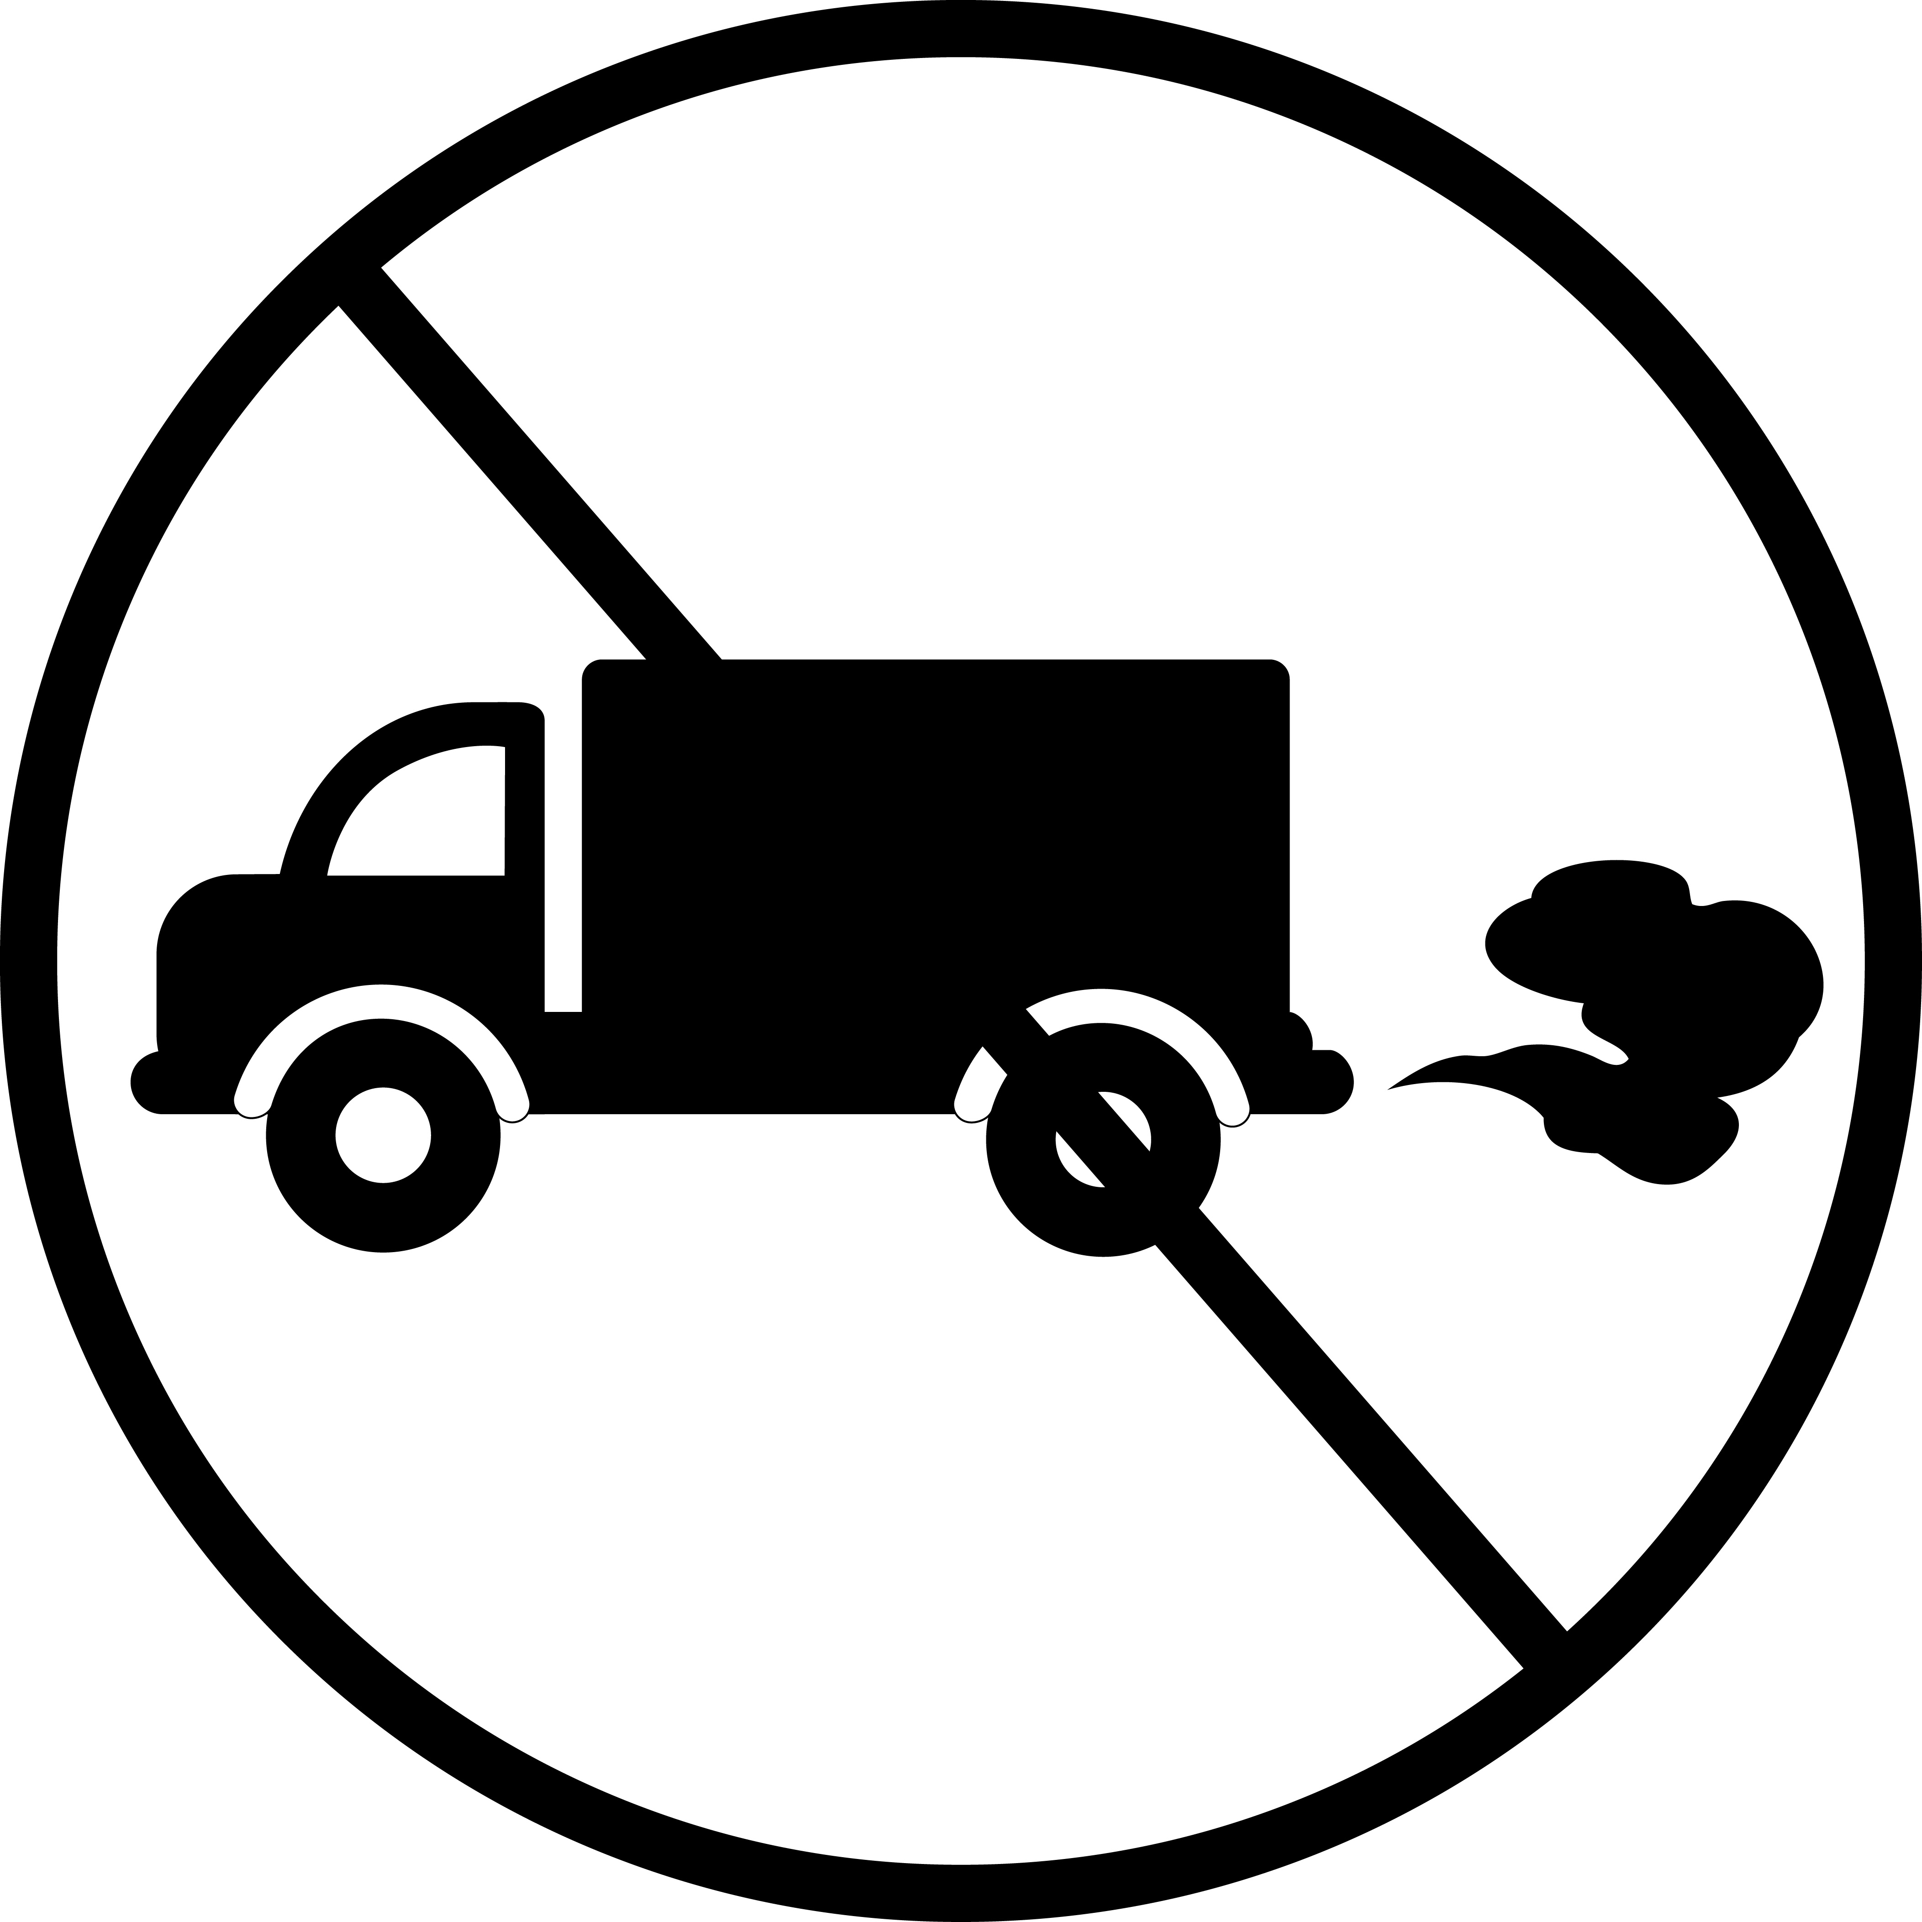
California Code of Regulations Title 13

Project Site Contact: Jane Doe  Jane Doe Construction  555-555-5555  JaneDoe@Construction.com | Contract Department Contact: John Doe  City Department  555-555-5555  John.Doe@sfgov.org

NOTICE
PROJECT SUBJECT TO CLEAN CONSTRUCTION ORDINANCE
San Francisco Environment Code Section 25.5

All off-road equipment shall have Tier 2 engines and Level 3 (or higher) VDECS OR
Tier 4 engines

The Public may ask to inspect the Project’s Construction Emissions Minimization Plan at any time during work hours.

Project Site Contact: Jane Doe  Jane Doe Construction  555-555-5555  JaneDoe@Construction.com | Contract Department Contact: John Doe  City Department  555-555-5555  John.Doe@sfgov.org

