|  |  |
| --- | --- |
| City and County of San Francisco  London N. Breed, Mayor  San Francisco Department of Public Health  Greg Wagner, Acting Director of Health | **San Francisco Department of Public Health**  Office of Compliance and Privacy Affairs  C:\Users\maria martinez\AppData\Local\Temp\PHD Logo.gifcid:image003.png@01D2FFBD.715C6C70 |

DPH PATIENT DATA EXTERNAL SHARING REQUEST FORM

# What is this form?

This form will help you determine if approval is needed before sharing data, and will guide you in obtaining that approval.

SFDPH wants to ensure that as an organization we are sharing patient data with our external partners…

* **Legally**: do we have the right to share the data?
* **Securely**: can we send the data safely from a technological perspective?
* **Appropriately**: are we sharing the minimum necessary amount of Protected Health Information (PHI)?

This form can be found online here: https://www.sfdph.org/dph/files/HIPAAdocs/PrivacyPolicies/DataRequestForm.docx

# Who should use this form?

* **Anyone sharing DPH patient data with a new external partner**, namely an individual or organization outside of DPH or DPH’s affiliated UCSF partners, that hasn’t received the data before**.** Existing data sharing arrangements can remain for now, but may be reviewed at a later date.
* **Anyone who needs to know which data sharing policies apply to their data sharing situation.** This form guides you through various data sharing scenarios, and provides links to the relevant Office of Compliance and Privacy Affairs (OCPA) guidelines here: <https://www.sfdph.org/dph/comupg/oservices/medSvs/HIPAA/HIPAAPolicies.asp>.
* **People who have already identified the data fields needed, and are able to pull the data.** If you need help identifying and pulling data, you may contact one of the data groups below. Priorities for data support requests may need to be set by the Office of Health Informatics (OHI).

|  |  |  |
| --- | --- | --- |
| **Data Group** | **Contact them if…** | **Contact them at…** |
| Metrics, Analytics and Data Integration (MADI) and  Project Management Office (PMO) | You need financial data.  You are not working at ZSFG campus. | [dph.helpdesk@sfdph.org](mailto:dph.helpdesk@sfdph.org)  and note that you are making a MADI data request |
| ZSFG Quality Data Center (QDC) | You are working out of ZSFG or the campus clinics. | <http://in-sfghweb02.in.sfdph.net/DataCenter/submit-a-data-request/> |

# Things to remember

* Everyone at DPH who encounters data must take the Privacy and Compliance trainings annually: <https://www.sfdph.org/dph/comupg/tools/PrivacyCompTrainingInstructions-02.16.17.pdf>
* Protected Health Information (PHI) and confidential data need to be encrypted when sent outside the organization.
* If you want someone to have access into a DPH system, managers/supervisors must fill out the [Computer Account Request Wizard User Log In page](http://in-sfghweb03.in.sfdph.net/NewReportRegistry/IDRequest/). DPH is currently only granting urgent requests for external access, as the process for provisioning is being revised. If you want an external party to have access to a system, contact OCPA at [DataSharing@sfdph.org](mailto:DataSharing@sfdph.org).
* If you want a colleague within DPH to have access to a Shared Drive, send a service request to [dph.helpdesk@sfdph.org](mailto:dph.helpdesk@sfdph.org) and request the ticket be assigned to the DPH Server Team.

# High Level Process

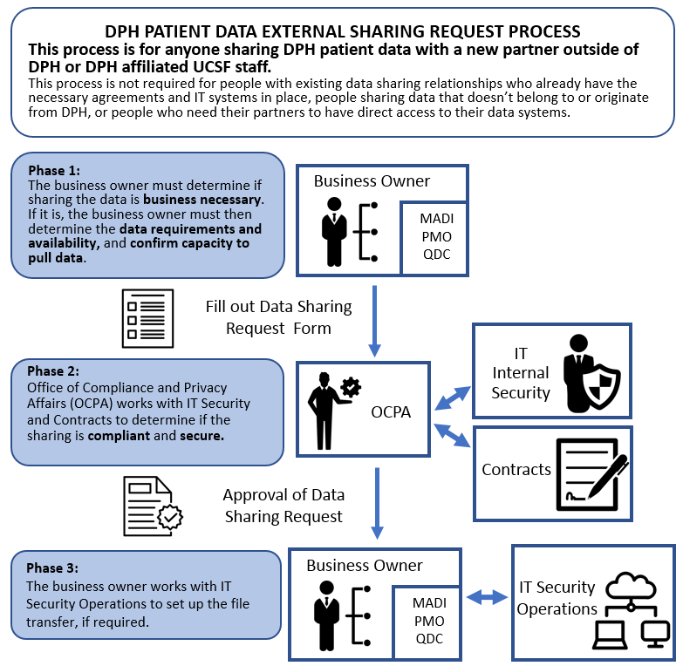

# How do you use this form?

**Answer the questions and follow the prompts** throughout this form to identify your data sharing situation and the associated course of action.

* **Section 1: Determine if form completion is required.**

A number of data sharing circumstances outlined in Section 1 do not require OCPA or IT Security approval. If these circumstances apply, you do not need to fill out or submit this form.

* **Section 2: Provide basic contact information.**

Identify the contacts who are sending and receiving the data, and if the data is being sent for regulatory or financial purposes.

* **Section 3: Provide the business need and details regarding the data.**

Fill out more detailed information about the request and submit the form for approval. Attach any supporting documentation that may assist OCPA in evaluating and processing the request.

**Then e-mail the word document to OCPA** at[DataSharing@sfdph.org](mailto:DataSharing@sfdph.org).

# Section 1: Do I Need to Complete This Form and Obtain Approval?

|  |  |
| --- | --- |
| **Are you sharing data with colleagues within DPH or DPH affiliated UCSF staff?** | Yes  No |
| Yes 🡪 okay to share. Includes working with MADI, PMO and QDC. |  |

|  |  |
| --- | --- |
| **Is this for a law enforcement or disciplinary investigation?** | Yes  No |
| Yes 🡪 contact the Privacy Office at [compliance.privacy@sfdph.org](mailto:compliance.privacy@sfdph.org) or (855) 729-6040 and read the Law Enforcement policy [C11.0](https://www.sfdph.org/dph/files/HIPAAdocs/PrivacyPolicies/DPHRequestsFromLawEnforcement.pdf) or Disciplinary Investigations policy [C4.0](https://www.sfdph.org/dph/files/HIPAAdocs/PrivacyPolicies/DPHPolicyUseofPHIinDisciplinaryInvest-Adopted01-12-09.pdf). |  |
|  |  |
| **Is this sharing approved by an Institutional Review Board (IRB)? (Research or Quality Improvement projects)** | Yes  No |
| Yes, through UCSF IRB 🡪 Refer to [Academic Research System (ARS)](https://it.ucsf.edu/about/teams/academic-research-systems)  Yes, through DPH 🡪 Refer to Conduct of Research Policy [E1.0](https://www.sfdph.org/dph/files/HIPAAdocs/PrivacyPolicies/HIPAAPrivacyConductResearchPol051311.pdf). |  |
|  |  |
| **Is this for treatment of an individual patient by a treatment provider?** | Yes  No |
| Yes 🡪 okay to share. See policy [C3.0](https://www.sfdph.org/dph/files/PoliciesProcedures/DPH_Privacy_Matrix_12192013.pdf) for the definition of treatment and treatment providers. Questions? Contact the Privacy Office at [compliance.privacy@sfdph.org](mailto:compliance.privacy@sfdph.org) or (855) 729-6040. |  |
|  |  |
| **Is this part of a mandated duty to report?** | Yes  No |
| Yes 🡪 okay to share. Read policies [C5.0](https://www.sfdph.org/dph/files/CBHSPolProcMnl/3.06-09.pdf) (client threat), [C6.0](https://www.sfdph.org/dph/files/CBHSPolProcMnl/3.06-11.pdf) (child abuse and neglect), [C7.0](https://www.sfdph.org/dph/files/CBHSPolProcMnl/3.06-13.pdf) (elder abuse), [C8.0](https://www.sfdph.org/dph/files/HIPAAdocs/PrivacyPolicies/RptingLapseConsciousness2DMV01122009_0%5b1%5d.pdf) (lapse of consciousness), [C10.0](https://www.sfdph.org/dph/files/HIPAAdocs/PrivacyPolicies/DPHVictimsofElderChildAbuse.pdf) (abuse and assault).  Questions? Contact the Privacy Office at [compliance.privacy@sfdph.org](mailto:compliance.privacy@sfdph.org) or (855) 729-6040. |  |
|  |  |
| **Are you sending directly to a patient or their legal representative?** | Yes  No |
| Yes 🡪 okay to share. If sending information electronically, read policies [D1.2](https://www.sfdph.org/dph/files/HIPAAdocs/PrivacyPolicies/DPH_ElectronicMessagingAdultPatientsPolicy_FINAL.pdf) and [I15.0](https://www.sfdph.org/dph/files/HIPAAdocs/memos/2016-06-03-AllStaffMemoEmailMessagingPatients.pdf). Questions? Contact the Privacy Office at [compliance.privacy@sfdph.org](mailto:compliance.privacy@sfdph.org) or (855) 729-6040. |  |

|  |  |
| --- | --- |
| **Is this part of a public records request?** | Yes  No |
| Yes 🡪 Please contact the Public Information Officer at [PublicRecords.dph@sfdph.org](mailto:PublicRecords.dph@sfdph.org) or (415) 554-2716. Read the [Requests for Public Records & Subpoenas](https://www.sfdph.org/dph/comupg/records/reqPublRecs/default.asp) guidelines. |  |

**If you answered Yes to any of the questions above, do not fill out or submit this form.**

If you need IT support to physically transfer your Special Circumstances data, fill out

form Sections 2 and 3B. Send a service request to [dph.helpdesk@sfdph.org](mailto:dph.helpdesk@sfdph.org), noting that you need technical assistance with sharing data from DPH IT Security Operations. **If you answered No to all the questions above, continue with the form**.

**No IRB, but wondering if it’s research?**

**Are you a care provider but want to share data regarding multiple patients?**

You need to determine if your reason for sharing is for research or health care operations: see policy [I3.0](https://www.sfdph.org/dph/files/HIPAAdocs/memos/2015-11-04-OCPA-AllStaff.pdf).

Key question: Will the data be used to inform a process in real time? Yes  No

Yes 🡪 It should be considered health care operations related to quality improvement (QI). If sharing DPH data with an external partner, continue to fill out this form.

No 🡪 It should be considered research, see above.

**Complete the following sections to the best of your ability and submit the completed form to the Office of Compliance and Privacy Affairs** **(OCPA) at** **[DataSharing@sfdph.org](mailto:DataSharing@sfdph.org).**

# Section 2: Contact Information

**Date: _________________**

**DPH Business Unit Making this Request:**

|  |  |
| --- | --- |
| Unit name: | Location: |
| Primary contact name: | Phone: |
| E-mail: |
| Secondary contact name: | Phone: |
| E-mail: |

**Associate Entity Receiving Data:**

|  |  |
| --- | --- |
| Entity name: | Location: |
| Primary contact name: | Phone: |
| E-mail |
| Secondary contact name: | Phone: |
| E-mail: |

**When do you need the data sharing to start?** Date: _____________

|  |  |
| --- | --- |
| **Will the data be submitted to a mandated reporting registry?** | Yes  No |
|  |  |
| **Will the data be required for regulatory compliance, patient safety or an audit?** | Yes  No |
|  |  |
| **Will the data be sent as part of routine financial processes?** | Yes  No |

# Section 3: Supporting Information

**Attach relevant agreements (scope of work, contract, MOU) or data documentation that you may have.**

## Business Requirements

**Supervisor approving the project/data transfer:**

|  |  |
| --- | --- |
| Supervisor name: | Phone: |
| Supervisor title: | E-mail: |

**State business need for data transfer.** Describe the nature and type of data being transferred.

|  |
| --- |
|  |

**How long is the data sharing needed for? __________________________________________**

**Indicate the type of external party receiving the data (choose all that apply):**

Business Associate  Covered Entity  Vendor  Consultant  Non-contracted provider

Unknown  Other: ___________________________

|  |  |
| --- | --- |
| **Is there an agreement in place with the external party?** | Yes  No  Don’t know |
| If yes: MOU  BAA  Contract  Purchase Order  Other  : _______________ | |
| Attach agreement or provide details, if known (e.g. agreement number, date, agreement holder): | |

|  |  |
| --- | --- |
| **Does the data contain PHI or sensitive information (e.g. names, dates of service, locations, medical record number)?** | Yes  No |

|  |  |  |
| --- | --- | --- |
| **Has the data been de-identified of PHI identifiers?**  Please see list of identifiers under the “Safe Harbor Method” [De-identification Standard](https://www.hhs.gov/hipaa/for-professionals/privacy/special-topics/de-identification/index.html#standard). | | Yes  No |
| If yes, please indicate whether the data retains limited identifiers or is fully de-identified: | | |
| **Limited ID PHI**  No names  No telephone, Fax, Email. | **De-Identified Health Information**  No Names  No Account/Record Numbers*  No telephone, Fax, Email.  No geographic designations smaller than state*  No dates (including birth or death), or age over 89* | |
| *See the [DPH Health Information Data Use Agreement](https://www.sfdph.org/dph/files/HIPAAdocs/PrivacyPolicies/FormHealthInformationDataUseAgreementForm_revised041411.pdf) for more information. | | |
| If yes, provide method of de-identification: | | |
| **What is the number of records in the data set?** 2-50  51-499  500+ | | |
|  | | |
| **Does the data request meet the minimum necessary standard?** | | Yes  No |
| You must make reasonable efforts to use or disclose only the minimum amount of PHI needed to accomplish the intended purpose of the use or disclosure. If unsure, check with your supervisor. | | |

## Technical Details

**Mechanism for intended data transfer:**

Managed File Transfer (MFT)  e-mail  upload to external party portal  mail service or fax

Don’t know – I’d like IT advice  Other  : ______________________

If e-mailing PHI data to a colleague, read memo [I11.0](https://www.sfdph.org/dph/files/HIPAAdocs/memos/2016-02-22-OCPA-AllStaff-EmailingandPHI.pdf).

If you are considering using a cloud-based shared drive, read memo [I5.0](https://www.sfdph.org/dph/files/HIPAAdocs/memos/2015-12-15-OCPA-AllStaff.pdf).

If you are sending PHI by mail or fax, read policy [D1.0](https://www.sfdph.org/dph/files/HIPAAdocs/PrivacyPolicies/DPHPrivacyProc4SecureDelPHIInterofficeMailFax05132010.pdf).

**Data transfer needs to be:**

inbound  outbound  both

**Does data need to be encrypted end to end?** PHI must always be encrypted.

yes  no  not sure

**How often will the data be transferred?**

one time  daily  weekly  monthly  occasionally

**When will the data transfer stop? _______________________________________**

**What will be the approximate average file size? _________________**

**What will be the approximate maximum file size**? **________________**

**Will the transfers be a manual process**  **or automated** **?** Not sure

**Will the transfers be scheduled**  **or unscheduled** **?** Not sure

If scheduled, when will they be scheduled? **____________________________**

**Once transferred, where will the data be stored? ___________________________**

Are backup and archival processes in place? **______________________________**

# Execution – to be filled out by OCPA & IT Security

**Data: Approved**   
Notes:

**Data Security: Approved**

Notes:

**Purpose: Approved** Notes:

Date approved: _________________

Authorized until [*date*] via [*agreement number or regulation*].

*Once Approved, send form back to the data sharing requestor.*

If you need technical assistance setting up the data transfer, contact the Service Desk at [dph.helpdesk@sfdph.org](mailto:dph.helpdesk@sfdph.org) and note that you are requesting IT Security support in setting up a data transfer.

**Data transfer technical assistance: Completed**

Notes:

Date technical assistance completed: _________________

*Once completed, send form back to the data sharing requestor.*