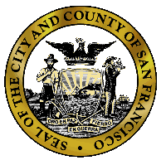  City and County of San Francisco  Edwin M. Lee, Mayor | San Francisco Department of Public Health  Barbara A. Garcia, MPA  Director of Health
San Francisco Department of Public Health

Policy & Procedure Detail*
Policy & Procedure Title: Click here to enter text.

Category: Choose an item.
Effective Date: Click here to enter a date. |  | Last Reissue/Revision Date: Click here to enter a date.
DPH Unit of Origin: Click here to enter text.
Policy Contact - Employee Name and Title; and/or DPH Division:
Click here to enter text.
Contact Phone Number(s): Click here to enter text.
Distribution: DPH-wide | If not DPH-wide, other distribution:
*All sections in table required. Updated 3/2014

Purpose of Policy

Policy

Definitions

Procedures

References/Attachments

